

UNDERGRADUATE PROJECT PROGESS REPORT

|  |  |
| --- | --- |
| **Project Title:** | **Inception-Enhanced Depthwise CNN of Residual Learning for Breast Cancer Diagnosis** |
| **Surname:** | **Wu** |
| **First Name:** | **Keliang** |
| **Student Number:** | **202018010212** |
| **Supervisor Name:** | **Dr Grace Ugochi Nneji** |
| **Module Code:** | **CHC 6096** |
| **Module Name:** | **Project** |
| **Date Submitted:** | **26/12/2023** |

**Table of Contents**

1 Introduction 4

1.1 Background 4

1.2 Aim 4

1.3 Objectives 5

1.4 Project Overview 5

1.4.1 Scope 5

1.4.2 Audience 6

2 Background Review 7

3 Technical Progress 9

3.1 Approach 9

3.1.1 Inception Network Version 4 (V4) 9

3.1.2 Residual Network 9

3.1.3 Inception-ResNet Block 10

3.1.4 Depthwise Convolution Model 11

3.1.5 Depthwise-Inception-ResNet Model 11

3.2 Dataset 12

3.2.2 Data Separation 12

3.2.3 Data Balance 13

3.2.4 Data Resize 14

3.2.5 Data Colour Channel Modification 14

3.2.6 Data Augmentation 15

3.3 Technology 15

3.4 Testing and Evaluation Plan 15

3.4.1 Data testing 15

3.4.2 Model Performance Evaluation Criteria 16

3.5 Experiment and Results 17

3.5.1 InceptionNet Training on four Magnifications 17

3.5.2 ResNet Training on Four Magnifications 24

3.5.3 Inception-ResNet Training on 40X magnifications 27

3.5.4 Depthwise CNN training on 40X magnifications 29

3.5.5 Inception-ResNet-Depthwise Training on 40X Magnifications 30

3.5.6 Current Experiments Results Summary 32

4 Project Management 34

4.1 Activities 34

4.2 Schedule 35

4.3 Project Version Management 35

4.4 Project Data Management 36

4.5 Project Deliverables 36

5 Professional Issues and Risk: 37

5.1 Risk Analysis 37

5.2 Professional Issues 37

6 References 39

# **Introduction**

## **Background**

Breast cancer is one of the most fatal diseases so far in the world. It is said by American Cancer Society Surveillance that one out of eight women is affected by it [1]. According to statistics recorded by the World Health Organization (WHO) [2] among the 9.6 million cancer-related deaths, 627,000 females passed away due to breast cancer in 2018, in addition, WHO had also predicted that 43,600 women would die from breast cancer in 2021 [3], which indicates that breast cancer remains the leading cause of women death.

Breast cancer is similar to other types of cancer which can be early-stage (Benign) and later-stage (Malignant). Once the disease reaches the malignant stage, cancer might spread to other parts of the body which leads to catastrophic results, therefore, it is crucial to detect breast cancer at the early stage in order to provide appropriate treatment [4]. Mammography serves as a common approach for breast cancer detection in which the picture is normally taken through Magnetic Resonance Imaging (MRI), X-Ray, and Ultrasound, other methods rely on tissue samples from the affected area of the breasts and complete the diagnosis and classify by microscope [5].

It is unfortunate that the diagnosis still faces troubles. Manual diagnosis through medical images or microscope is time-intensive, expensive and prone to errors, as symptoms are likely to be overseen [6]. For example, ultrasound breast cancer image detection highly depends on the experience, capability and knowledge of radiologists and diagnosticians [7], which most small hospitals might not be equipped with.

Therefore, the development and deployment of a deep learning based system focused on the classification and diagnosis of breast cancer is the main goal of this project so as to avoid manpower waste, apply more targeted treatment to patients, lower death rate, and save more lives.

## **Aim**

Various models in deep learning diagnosis utilize a specific single model, however, by doing so, there are chances that flaws of specific models could affect the performance in a negative way. To eliminate the drawbacks and maximize the performance, this project aims to develop and deploy a novel CNN model including Inception-ResNet model to classify the levels of breast cancer. Based on Wang et al. [8], Inception-ResNet possesses a remarkable balance between model accuracy and resource efficiency.

## **Objectives**

The project will collect breast cancer symptom data from online sources, utilizing datasets like BreakHis, IDC, and mini-DDSM. BreakHis has benign and malignant categories with 9,109 microscope images from 82 patients. IDC contains 198,738 negative and 78,786 positive invasive carcinoma images. The data will be divided into training and testing sets for four different scaled images, with an 80% portion allocated for training and a 20% portion for testing. Within the training set, 10% of the images will be randomly selected as a validation set. It is essential to include both benign and malignant samples in both sets.

The project aims to build a Depthwise-Inception-ResNet-Attention model, with hyperparameter adjustments such as batch size, learning rate, dropout rate etc. Although primarily focused on binary classification, the project also approaches it as a multi-class problem to later identify more detailed symptoms and enhance generalizability.

In addition, the evaluation of the model will include metrics such as "Accuracy" and "Loss." Moreover, performance will be assessed using "Precision", "Recall", "F1-Score", "AUC-ROC", "AUC-PR", "Specificity", "Sensitivity", and the "Confusion Matrix”.

Lastly, the project will be deployed through a website which allows uploading medical pictures of breast cancer, and then give the classification results.

## **Project Overview**

### **Scope**

Convolutional Neural Networks (CNNs) were introduced to medical image processing in the 1980s and have become the dominant approach in this field [9]-[10]. While Inception-ResNet delivers impressive performance, models not tailored to specific scenarios often encounter issues like gradient vanishing, local minima, and overfitting. Therefore, enhancing Inception-ResNet through the incorporation of depthwise operations is imperative. By using depthwise operations, it will reduce the parameter count, thus, improving the network's efficiency and effectiveness, all the while conserving computational resources by eliminating unnecessary parameters [11].

The following are the significances of this project and potential contributions:

* Enhanced Breast Cancer Diagnosis Accessibility
* Improved Diagnosis Efficiency
* Reduced Misdiagnosis Rate
* Early detection and Prevention
* Conserved Medical Resources and Improved Allocation
* Increased Life Saving Rate
* Cost-Effective Healthcare Solutions
* Promotion of Public Health Awareness

### **Audience**

The development of a specialized system for breast cancer diagnosis will bring about significant benefits to various stakeholders.

**Medical Professionals:** Radiologists and oncologists will benefit from the enhanced accuracy and efficiency of breast cancer diagnosis. The CNN can aid in early detection, reducing the chances of misdiagnosis and allowing for more timely interventions.

**Hospitals and Clinics:** Healthcare institutions will experience improved workflow and reduced diagnostic errors, which can lead to better patient care and outcomes. It can also streamline the diagnostic process, potentially reducing the burden on healthcare resources.

**Breast Cancer Patients:** Patients will benefit from faster and more accurate diagnosis, resulting in quicker treatment initiation and improved chances of survival. Additionally, reduced false positives and negatives can alleviate the emotional stress associated with diagnostic uncertainty.

**Medical Researchers:** Researchers can access a valuable tool for analyzing a vast amount of medical imaging data, facilitating advancements in breast cancer research and treatment methods.

In summary, the proposed depthwise-Inception-ResNet model promises benefits for medical professionals, healthcare institutions, breast cancer patients, and the broader research community by enhancing the accuracy, efficiency, and overall quality of breast cancer diagnosis and care.

# **Background Review**

Various methods had enhanced breast cancer classification. This section will present works that had been done for breast cancer classification.

Hirra et al. [1] proposed Pa-DBN-BC, a patch-based deep learning method, achieving 86% accuracy in diagnosing cancer from histopathology images. Sahu et al. [6] introduced a model trained on mini-DDSM, yielding 99.17% and 97.75% accuracy for abnormalities and malignancy. Liang and Meng [9] achieved high accuracy in binary and eight-class classification with BreakHis datasets. Alkhaldi et al. [11] utilized ensemble optimization, attaining 92.874% accuracy in Invasive Ductal Carcinoma classification.

Xu et al. [13] introduced an attention mechanism network with 98% accuracy, albeit limited by the smaller BreakHis dataset. Wu et al. [14] trained on 224,426 mammography images, reaching an AUC of 0.895. Chougrad et al. [15] employed transfer learning, achieving 98.94% accuracy post-merging datasets. Yu et al. [16] used SCDA data augmentation with ResNet-50, obtaining 95.74% accuracy, 98.55% specificity, and 92.83% sensitivity. Arya and Saha [17] developed a stacked-based ensemble model with 90.2% accuracy for breast cancer prognosis. Whitney et al. [10] highlighted the efficacy of CNN transfer learning in diverse imaging modalities for accurate breast cancer diagnosis.

A summary of the different researchers and their findings and possible results can be found in Table 1.

|  |  |  |  |
| --- | --- | --- | --- |
| Author | Datasets | Methods & Models | Results |
| Hirra et al. [1] | Histopathology images | Patch-based deep learning & Deep belief Network | 86% |
| Sahu et al. [6] | Mini-DDSM &  Ultrasound  images(BUSI) | AlexNet+ResNet+MobileNeetV2 | Abnormalities: 99.17% and 97.75% mini-DDSM and BUSI  Malignancy: 96.92% and 94.62% mini-DDSM and ultrasound |
| Liang and Meng [9] | BreakHis | Convolutional Block Attention Module and Convolutional Multi-Layer Perceptron | 95.5% |
| Alkhaldi et al. [12] | Invasive-Ductal-Carcinoma (IDC) | Multi-ResNet CNN | 92.874% |
| Xu et al. [13] | BreakHis | DeNet | 98% |
| Wu et al. [14] | 224,426 mammography | Ensemble of Four ResNets | 0.895 in AUC |
| Chougrad et al. [15] | INbreast, DDSM, BCDR | VGG16, ResNet50, IncetpionV3 | DDSM: 97% accuracy, 0.98 on AUC;  INbreast: 95.5% accuracy, 0.97 on AUC  BCDR: 96.67% accuracy, 0.96 on AUC  Independent database (MIAS): 98.23% accuracy, 0.99 on AUC |
| Yu et al. [16] | INbreast, mini-DDSM | SCDA augmentation  & ResNet-50 | 95.74% accuracy, 98.55 specificity, 92.83% sensitivity |
| Arya and Saha [17] | 1,980 patients’ breast cancer data | stacked ensemble model | AUC of 0.93 and 90.2% accuracy |

Table 1: Summary of Related Works

# **Technical Progress**

## **Approach**

The proposed CNN model comprises two individual models with two mechanisms. The basic idea is to combine Inception-V4 Model, Residual Network, and integrate attention mechanism and depthwise convolution which are respectively used to concentrate on relevant features and to reduce the computation resources.

### **Inception Network Version 4 (V4)**

Inception V4, as shown in figure 1, introduced by Google researchers in 2016, is a deep learning architecture renowned for its advanced techniques, including inception modules that efficiently learn local and global features using filters of varying sizes. It excels in image recognition and offers scalability [18].

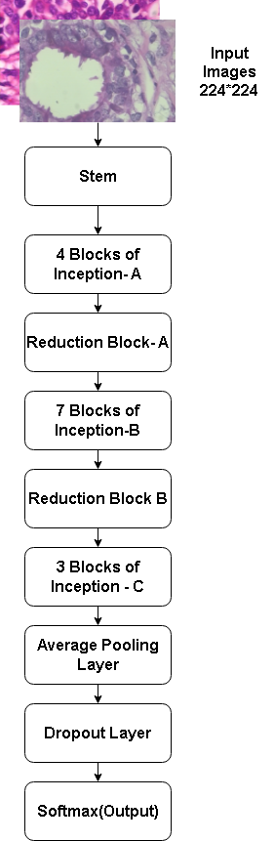

Figure 1: Inception V4 Architecture

### **Residual Network**

ResNet blocks, as illustrated in Figure 2, were introduced to incorporate residual connections, effectively mitigating gradient-related challenges in deep networks and leading to enhanced training efficiency [19].

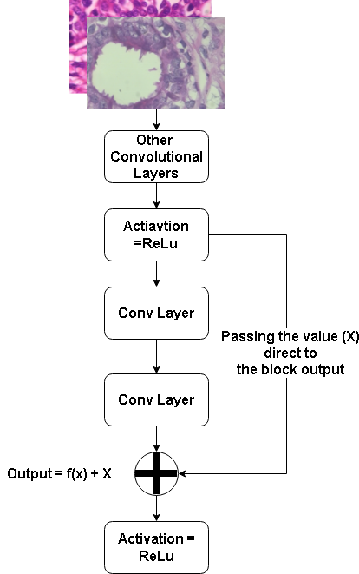

Figure 2: Basic ResNet Block

### **Inception-ResNet Block**

Figure 3 illustrates the fusion of Inception V4 with ResNet Blocks, creating the Inception-ResNet Blocks structure. This hybrid design incorporates the multi-path feature extraction of Inception with the gradient-enhancing properties of ResNet. By combining these elements, Inception-ResNet Blocks enable efficient learning of intricate features, leading to more accurate and effective deep learning models [19]. The diagram visually showcases the amalgamation of these techniques, highlighting their collaborative strength in enhancing the network's capabilities.

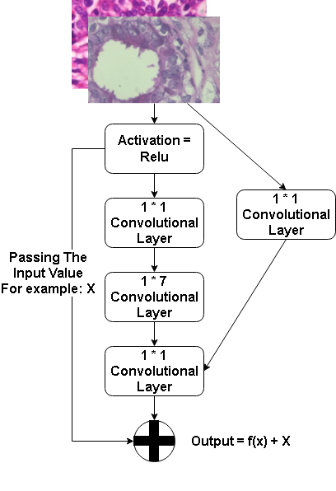 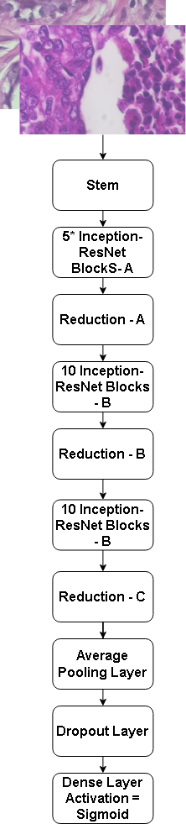

Figure 3: Inception-ResNet Block & Inception-ResNet Architecture

### **Depthwise Convolution Model**

As for depthwise convolution model, it is shown in figure 4 that instead of being an individual model, it is a convolution methodology which reduces the parameters by bypassing unnecessary parameters to deplete the model size and resource being taken [12].

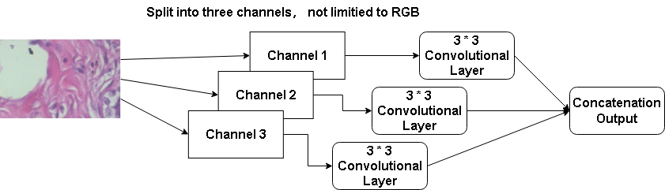

Figure 4: Depthwise Convolution

### **Depthwise-Inception-ResNet Model**

Therefore, Depthwise-Inception-ResNet model is constructed by combining all above which shown in figure 5.

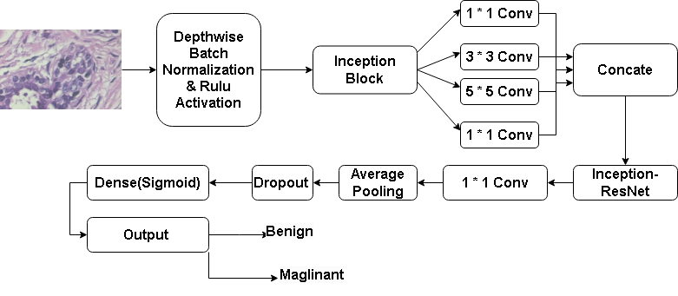

Figure 5: Depthwise-Inception-ResNet Network

Networks with attention mechanisms focus on specific areas for more relevant task-related features [20]. Attention combines a reference with keys to calculate scores, which are then used to determine importance, allowing concentration on specific information. The equations are as follows (equations 1-3).

Attention Score (Q, K) = Q * K^T (*1*)

Attention Weights (Q, K ) = softmax(Attention Score (Q, K)) (2)

Attention Values (Q, K, V)=Attention Weights(Q, K) * V (3)

The final network will be integrated with attention, therefore, it is shown in figure 6.

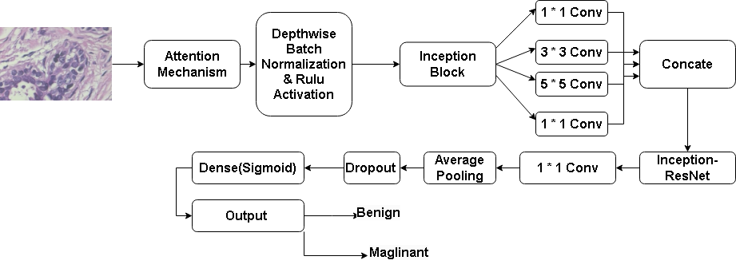

Figure 6: Depthwise-Inception-ResNet-Attention Network

## **Dataset**

* + 1. **Dataset Introduction**

During the training process, BreakHis will be the main dataset used for model training. The BreakHis dataset provides 9,109 histopathological images from 82 patients, categorized into 2,480 benign and 5,429 malignant samples at magnifications of 40X to 400X. Each RGB image has a resolution of 700 * 460 pixels. This dataset, created with the P&D Laboratory in Parana, Brazil, is instrumental for benchmarking in medical image analysis. It differentiates between non-invasive benign tumors and invasive malignant tumors capable of metastasis. Breast tumors are subtyped into adenosis, fibroadenoma, phyllodes tumor, and tubular adenoma for benign, and ductal carcinoma, lobular carcinoma, mucinous carcinoma, and papillary carcinoma for malignant, enabling detailed research studies. The nomenclature of each image provides insights into the biopsy type, tumor classification, patient ID, and magnification used.

### **Data Separation**

The BreakHis file has four symptoms in each benign and malignant. And each symptom contains four different magnifications. In the case that binary classification is the main goal of the project, the data are separated based on the magnifications of images. Then, inside each magnification, there are “train” folder and “test” folder which all contain benign and malignant. The above maneuver were completed through Python codes which had imported PIL(Pillow library) specialized for file management.

After copying the file into corresponding directories, data are then split using a random file selecting Python code to randomly move a proportion of images into test folders so as to reach the ratio of 85% : 15% between train folder and test folder. Rest of the separation of validation and training data will be done within the model coding.

The structure of the data separation is provided in figure 7.

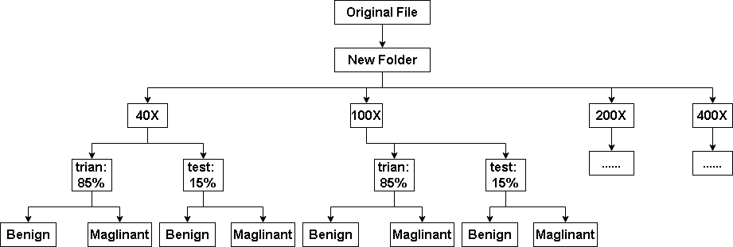

Figure 7: Dataset Structure

### **Data Balance**

Firstly, based on the figure 8 provided below, it is noticeable that within each magnification folder, the benign images are far less than malignant images, which makes the data unbalanced. Therefore, this project had applied oversampling for balancing the dataset, which is shown in figure 9.

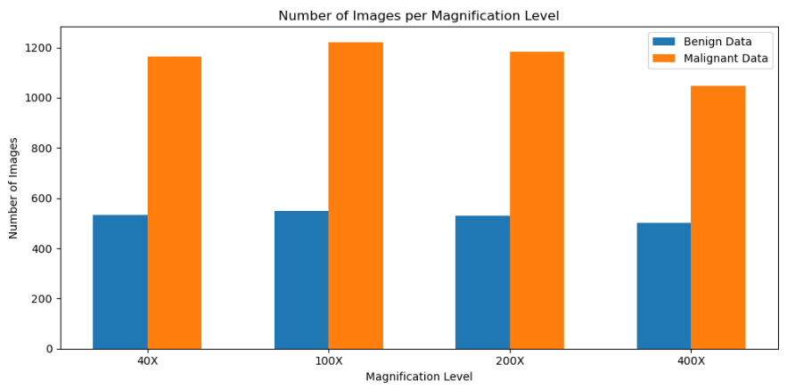

Figure 8: Number of images within Benign and Malignant Before Balancing

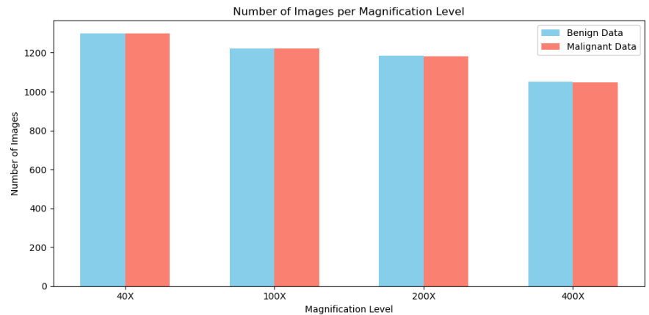

Figure 9: Images Number After Balancing

### **Data Resize**

As the introduction mentioned, the image resolution is 700 * 460 pixels, which does not fit in the proposed model input. And therefore, this project had resize the images of all magnifications into 224 * 224.

### **Data Colour Channel Modification**

This project had modified the images utilizing Contrast Limited Adaptive Histogram Equalization (CLAHE) which are then compared with the original image training results in order to select the better one. CLAHE operates by adaptively dividing the image into several small blocks, then performing histogram equalization on each of these blocks within certain contrast limits [21]. This approach improves the histogram distribution of the image, which is essential for enhancing detail and image quality. Images are displayed in the following figure 10.

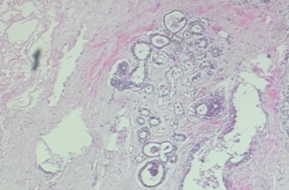 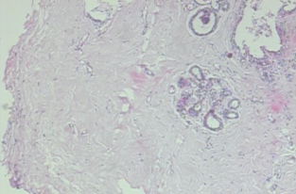 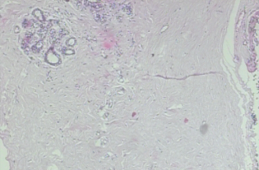

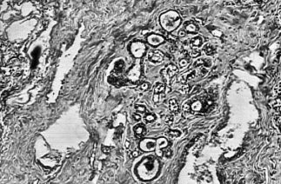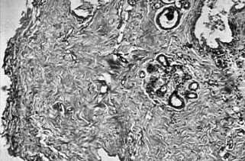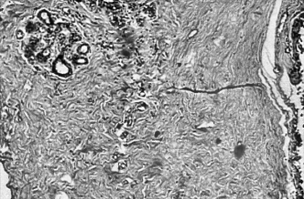

Figure 10: Images Transformation

### **Data Augmentation**

The BreakHis dataset is augmented with rotations (20 degrees), shifts (20% width and height), shear (20%), zoom (20%), and horizontal flips, alongside rescaling the pixel values by 1/255.

## **Technology**

The technology this project will be using is displayed in Table 2

|  |  |  |
| --- | --- | --- |
| Software | Framework | Tensorflow |
| Language | Python |
| Libraries and Application | Numpy, Keras, Matplolib, TensorFlow-Addons, Scikit-Learn |
| Hardware | Central processing unit(CPU) | Intel(R) Core(TM) i7-8750H CPU @ 2.2PGHz(12 CPUs), ~2.2GHz |
| Graphic Processing Unit(GPU) | NVIDIA GeForce GTX 2060 |

Table 2: Summary of Relevant Technology involved in this project

## **Testing and Evaluation Plan**

### **Data testing**

By checking the BreakHis datasets downloaded from Kaggle, it is estimated that some techniques of data pre-processing will be implemented which will be displayed below.

1. This project is will re-divide the original BreakHis datasets for binary classification. Considering the fact that there are four groups of magnifications of the histogram, this project will create four magnifications which contains two categories of breast cancer level from the original datasets.
2. The project will check the image size inside each magnification category and ensure the size of images are consistent, otherwise, resize techniques will be applied.
3. The project must separate the data into specific ratio for the purpose of training, validation and testing.
4. This project must check the number of each set, aimed at balancing the two categories. It will affect the model learning and diagnosis accuracy otherwise.
5. This project will apply few methods of data pre-processing on the datasets and test on model training in case there are any factors such as colour or contrast that affects training results.

### **Model Performance Evaluation Criteria**

This project will evaluate the performance of the model through following standards.

**Accuracy:** Accuracy is a quite intuitive metric and a criteria for evaluating model performances, which displays the overall correctness of a classification model. It calculates the ratio of the correctly predictions among the total predictions. The equation (4) is displayed below, where T, P, N, F represents, true, positive, negative and false. TP, TN, FP, and FN represent the counts of correctly identified positive cases, correctly identified negative cases, incorrectly identified positive cases, and incorrectly identified negative cases, respectively, in a classification model.

Accuracy $= \frac{TP+TN}{TP+TN+FP+FN}$ (4)

**Loss:** This criteria measures the cap between results of prediction labels and actual labels. Below shows the equation for classification.

Loss $= −\sum_{c=1}^{M}{y_{ic}}\log{(}P_{ic})$ (5)

**Precision:** This is the criteria that shows the proportion of images that are positively classified as positive. Equation is shown below in (6).

Micro Precision $= \frac{\sum_{i=1}^{n}{{ TP }_{i}}}{\sum_{i=1}^{n}{{ TP }_{i}}+\sum_{i=1}^{n}{{ FP }_{i}}}$ (6)

**Recall:** This is the criteria that displays the proportion positively identified as positive samples among the actual positive samples.

Micro Recall $=\frac{\sum_{i=1}^{n}{{ TP }_{i}}}{\sum_{i=1}^{n}{{ TP }_{i}}+\sum_{i=1}^{n}{{ FN }_{i}}}$ (7)

**F1-Score:** F1-Score measures the performance of model by calculating the harmonic mean of Precision and Recall.

F1 Score $=\frac{2 ×Micro Precision ∗Micro Recall}{Micro Precision + Micro Recall}$ ​ (8)

**Confusion Matrix:** It displays the accurate number of the True Positive, True Negative, False Positive and False Negative.

**ROC:** Receiver Operating Characteristic (ROC), which displays the trade-off relationships between the True Positive Rate(also known as sensitivity or recall) and the False Positive Rate of a model at different thresholds.

**AUC:** Area Under the ROC curve, which demonstrates the overall ability to distinguish between positive and negative samples. In the classification circumstance, AUC acts as metric to evaluate the performance of model for both classes. Generally speaking, a model is considered well performed when the curve rises towards the upper-left corner of the graph, and therefore, leaving more space to AUC. In a nut shell, the closer AUC gets to 1, the better the model is.

In summary, in order to evaluate the model performing on the binary classification of the level of breast cancer, this project will conduct a comprehensive evaluation, involving Accuracy, Loss, Precision, Recall, Precision-Recall Graph, F1-Score, Confusion Matrix, ROC graph, and AUC.

## **Experiment and Results**

The project's experiment involves utilizing individual models based on InceptionNet, ResNet, and Depthwise CNN architectures. These models are then integrated to form composite structures, creating various combinations of the three foundational architectures. The objective is to analyze the performance of these hybrid models under different combinations and identify the magnification level that yields optimal training results.

### **InceptionNet Training on four Magnifications**

The first two individual models provides not only the initial judgement of the performance on the BreakHis dataset, but also insights of which magnification works better for model training.

The pure InceptionNet is trained with original and resized version images which helps decide which scale of images should remained for further training. Results and Model details are provided below from figure11 to figure 22.

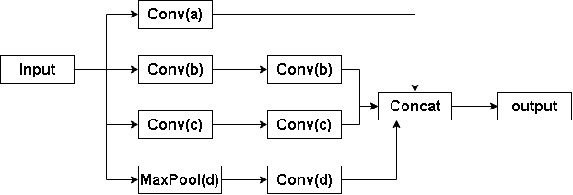

Figure 11: Initial Simple Inception Model

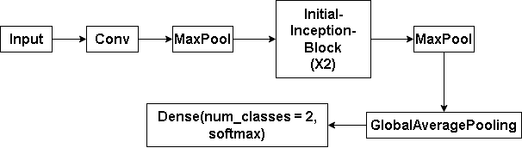

Figure 12: Initial InceptionNet

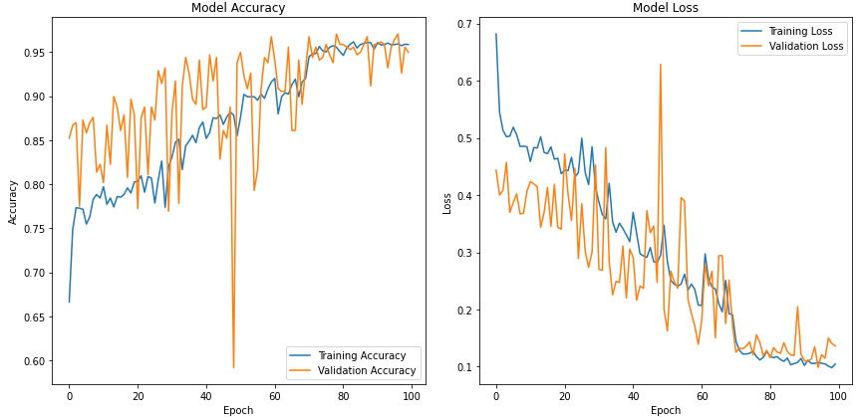

|  |  |
| --- | --- |
| 1. Train Acc = 0.9584, Val Acc = 0.9497 | 1. Train Loss = 0.1047, Val Loss = 0.1362 |

Figure 13 (a) and (b) present InceptionNet Accuracy and Loss of Train and Validation sets on 40X Raw Images

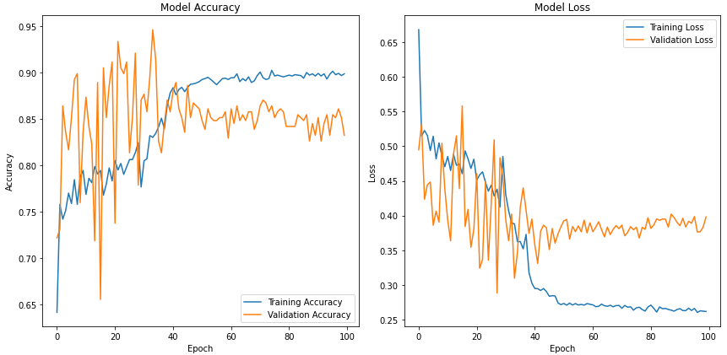

|  |  |
| --- | --- |
| 1. Train Acc = 0.8985, Val Acc = 0.8323 | 1. Train Loss = 0.2617, Val Loss = 0.3980 |

Figure 14 (c) and (d) display the InceptionNet Train and Validation Accuracy and Loss on 100X Raw Images

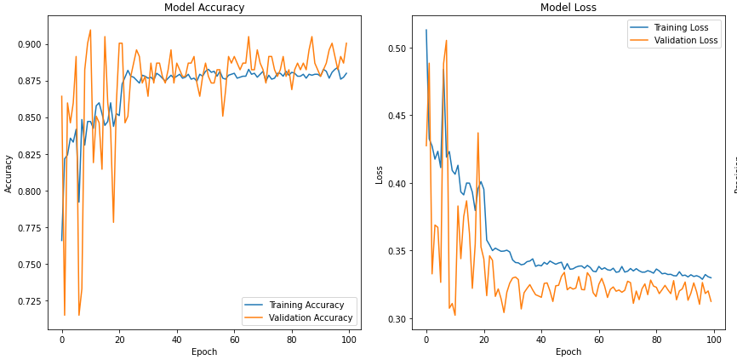

|  |  |
| --- | --- |
| 1. Train Acc = 0.8799, Val Acc = 0.9005 | 1. Train Loss = 0.3298, Val Loss = 0.3123 |

Figure15 (e) and (f) illustrate InceptionNet Train, Validation Accuracy and Loss on 200X Raw Images

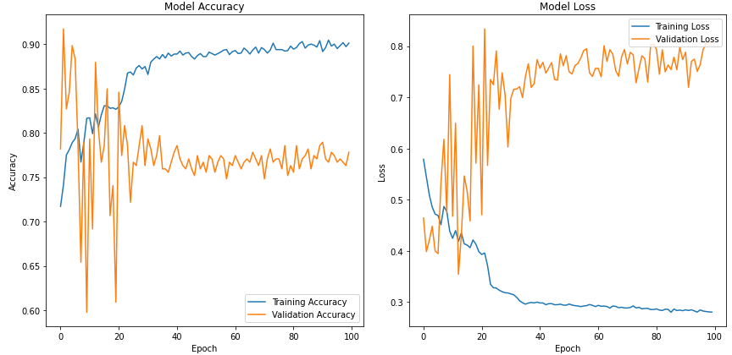

|  |  |
| --- | --- |
| 1. Train Acc = 0.9012 , Val Acc = 0.7782 | 1. Train Loss = 0.2804,Val Loss = 0.8079 |

Figure16 (g) and (h) demonstrate InceptionNet Train, Validation Accuracy and Loss on 400X Raw Images

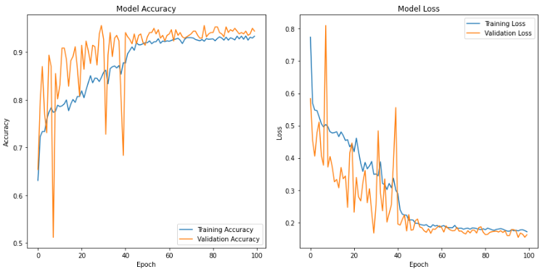

|  |  |
| --- | --- |
| 1. Train Acc = 0.9332, Val Acc = 0.9438 | 1. Train Loss = 0.1709, Val Loss = 0.1617 |

Figure17 (i) and (j) display InceptionNet Train, Validation Accuracy and Loss on 40X Resize Images

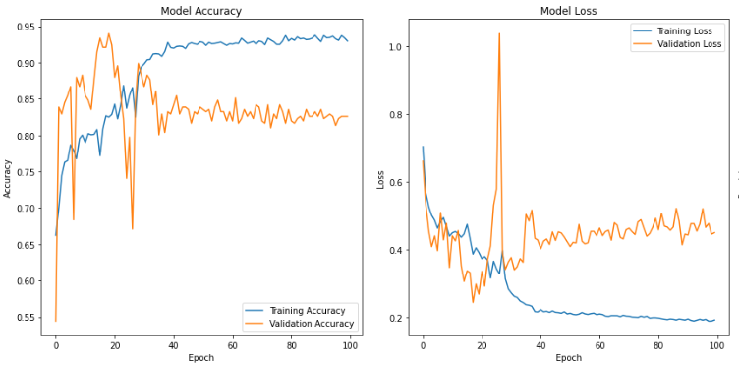

|  |  |
| --- | --- |
| 1. Train Acc = 0.9295, Val Acc = 0.8259 | 1. Train Loss = 0.1918, Val Loss = 0.4495 |

Figure 18 (k) and (l) display InceptionNet Train, Validation Accuracy and Loss on 100X Resize Images

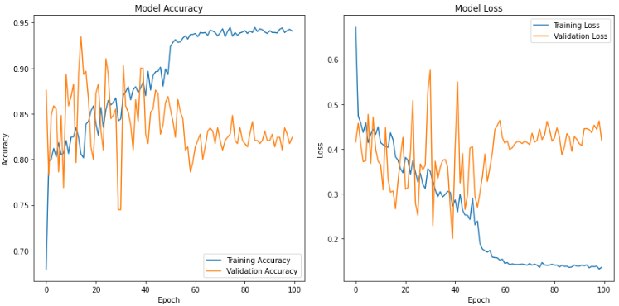

|  |  |
| --- | --- |
| 1. Train Acc = 0.9406, Val Acc = 0.8241 | 1. Train Loss = 0.1361, Val Loss = 0.4191 |

Figure 19 (m) and (n) present InceptionNet Train, Validation Accuracy and Loss on 200X Resize Images

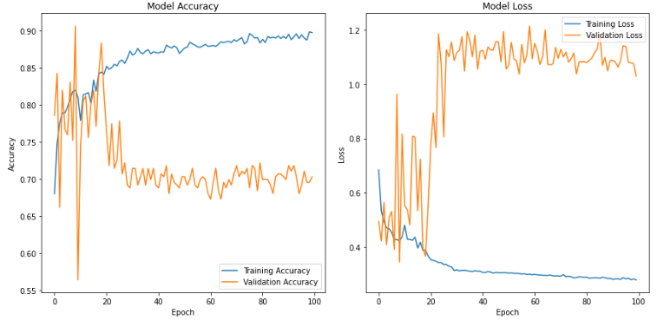

|  |  |
| --- | --- |
| 1. Train Acc = 0.8973, Val Acc = 0.7030 | 1. Train Loss = 0.2782, Val Loss = 1.0301 |

Figure20 (o) and (p) demonstrate InceptionNet Train, Validation Accuracy and Loss on 400X Resize Images

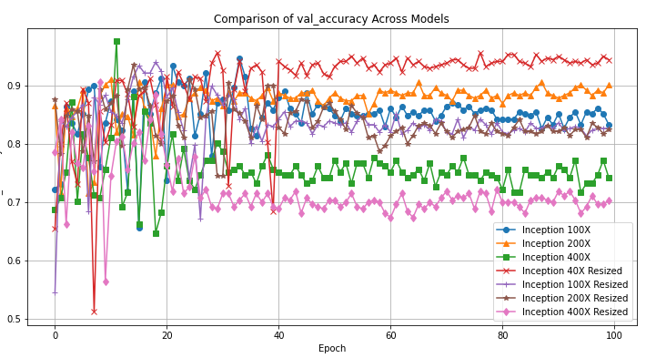

Figure 21: Comprehensive Comparison of Validation Accuracy Among Raw and Resized Images of Four Magnifications

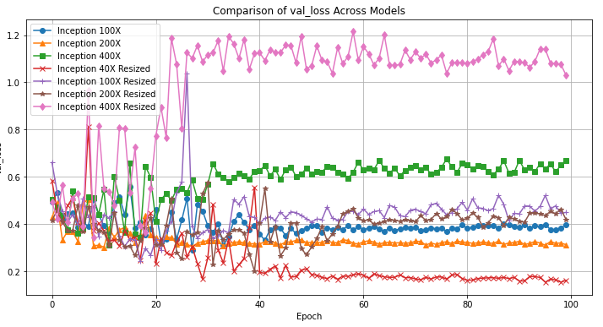

Figure 22: Comprehensive Comparison of Validation Loss Among Raw and Resized Images of Four Magnifications

Based on Figures 13 to 16, it is evident that without resizing the images, the model's performance during training varies among four magnification factors: 40X, 100X, 200X, and 400X. Notably, the model exhibits the best fitting performance when trained on images with a 40X magnification factor among these four options.

In Figures 17 to 20, after resizing the images to a size of 224 x 224 pixels to match the model input settings for this project, it is observed that, under the same four scenarios, the training performance of images with a 40X magnification factor continues to outperform the other three magnification factors.

Through the presentation of Figures 21 and 22, it becomes evident that most of the resized results surpass those without resizing. Furthermore, within this context, the training performance of images with a 40X magnification factor stands out as the most favorable. This phenomenon may be attributed to the fact that, at this magnification level, more details are captured, resulting in a richer set of features.

The upcoming experiment will further validate the suitability of magnification factors on resized images.

### **ResNet Training on Four Magnifications**

The initial ResNet was trained on four magnifications with resized images based on the last part results. Model details and results are presented from figure 23 to 29.

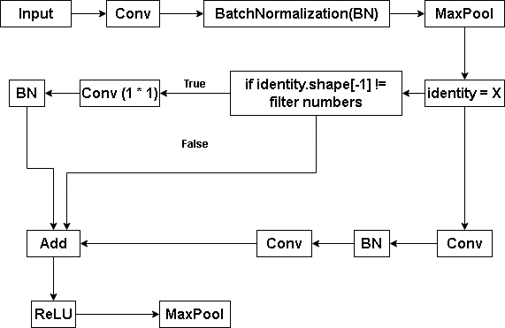

Figure 23: Initial Simple ResNet

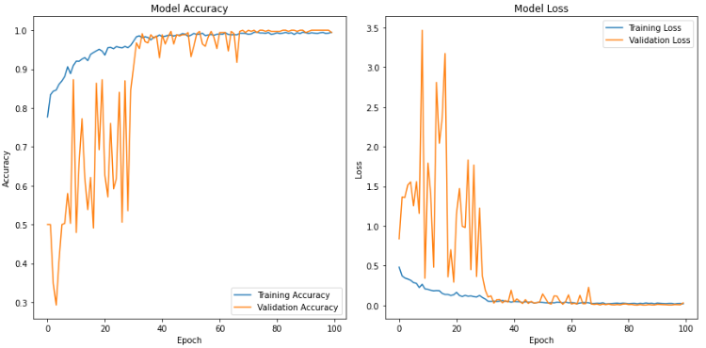

|  |  |
| --- | --- |
| 1. Train Acc = 0.9947, Val Acc = 0.9941 | 1. Train Loss = 0.0199, Val Loss = 0.0298 |

Figure 24 (q) and (r) illustrate ResNet Train, Validation Accuracy and Loss on 40X Resized Images

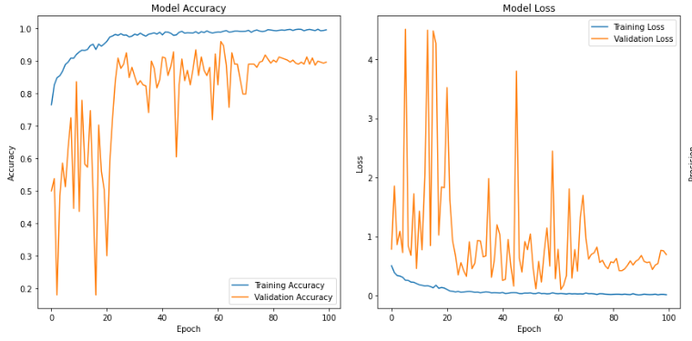

|  |  |
| --- | --- |
| 1. Train Acc = 0.9948, Val Acc = 0.8956 | 1. Train Loss = 0.0143, Val Loss = 0.6940 |

Figure 25 (s) and (t) display ResNet Train and Validation Accuracy and Loss on 100X Resized Images

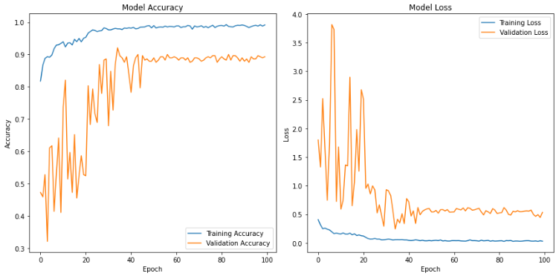

|  |  |
| --- | --- |
| 1. Train Acc = 0.9918, Val Acc = 0.8931 | 1. Train Loss = 0.0293, Val Loss = 0.5330 |

Figure26 (u) and (v) display ResNet Train, Validation Accuracy and Loss on 200X Resized Images

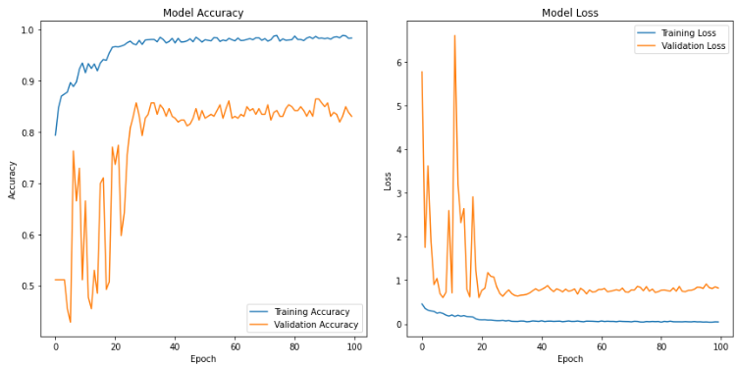

|  |  |
| --- | --- |
| 1. Train Acc = 0.9837 , Val Acc = 0.8308 | 1. Train Loss = 0.0459, Val Loss = 0.8232 |

Figure27 (w) and (x) display ResNet Train, Validation Accuracy and Loss on 400X Resized Images

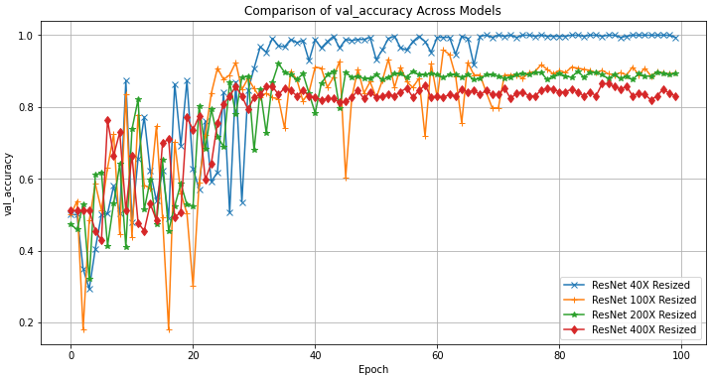

Figure 28: ResNet Validation Accuracy Comparison

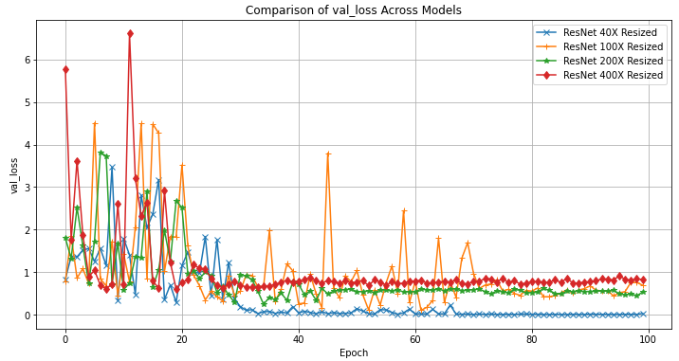

Figure 29: ResNet Validation Loss Comparison

Based on the results shown in the figures, it's evident that ResNet demonstrates improved accuracy across all magnification factors (40X, 100X, 200X, and 400X) after resizing compared to before. Notably, while magnifications of 100X, 200X, and 400X show clear signs of insufficient fitting capabilities, the 40X magnification stands out with excellent fitting and high accuracy. This observation is further supported by a comparison of figures 28 and 29. Consequently, moving forward, this project has chosen to focus on the 40X magnification for subsequent experiments and model training.

### **Inception-ResNet Training on 40X magnifications**

Figure 30 to 32 represent the structure of Inception-ResNet, and figure 33 illustrates the results training on the 40X magnified images.

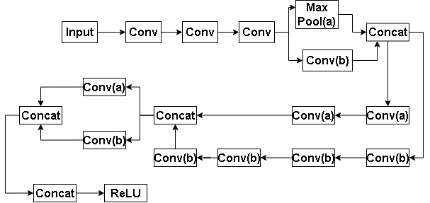

1. Inception-ResNet-STEM Block

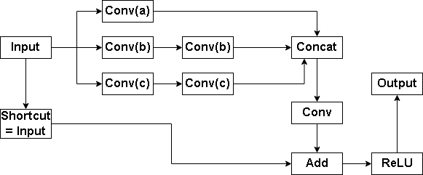 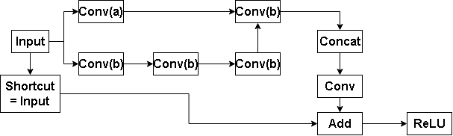

|  |  |
| --- | --- |
| 1. Inception-ResNet-A Block | 1. Inception-ResNet-B Block |

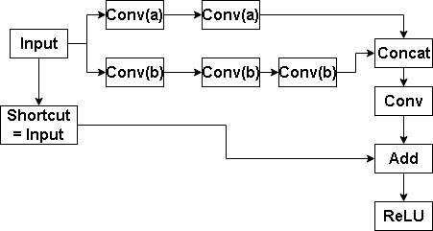

1. Inception-ResNet-C block

Figure 30 (1), (2), (3), and (4) Present the Main Blocks of the Implemented Inception-ResNet Network

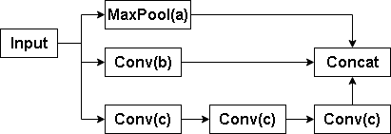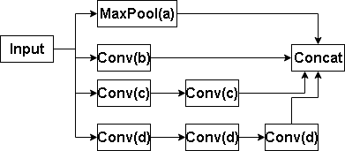

|  |  |
| --- | --- |
| 1. Parameters Reduction-A Block | 1. Parameters Reduction-B Block |

Figure 31(5) and (6) Demonstrate the Parameter Reduction Block within current Inception ResNet Block

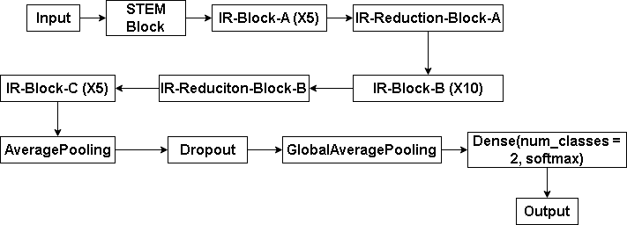

Figure32: Inception-ResNet Structure

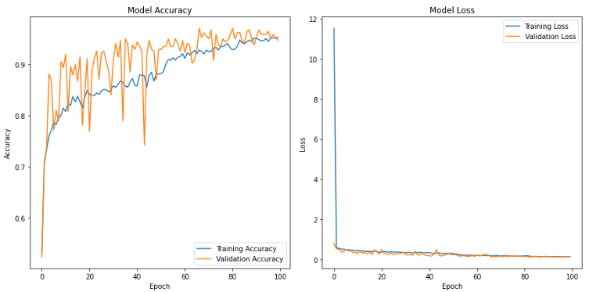

|  |  |
| --- | --- |
| 1. Train Acc = 0.9527, Val Acc = 0.9467 | 1. Train Loss = 0.1302, Val Loss = 0.1354 |

Figure 33 (y) and (z) display Train, Validation Accuracy and Loss on 40X Magnified BreakHis Resized images

### **Depthwise CNN training on 40X magnifications**

Before adding depthwise convolution, experiments of how individual depthwise convolutional network performs were applied as well. Figure 34 and 35 demonstrates the structure and results.

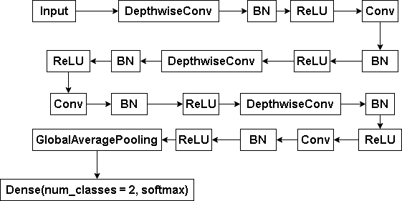

Figure 34: Basic Depthwise CNN Structure

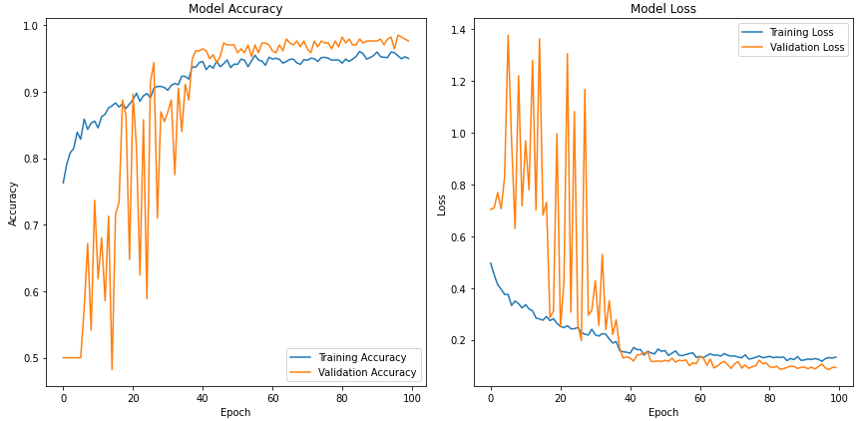

|  |  |
| --- | --- |
| 1. Train Acc = 0.9500, Val Acc = 0.9763 | 1. Train Loss = 0.1334, Val Loss = 0.0929 |

Figure 35 (aa) and (ab) display Depthwise-CNN Train, Validation Accuracy and Loss on 40X Magnified Images

### **Inception-ResNet-Depthwise Training on 40X Magnifications**

After getting the results of models above, these structures are integrated as a single model. By switching some of the convolutional layers within the Inception-ResNet to depthwise convolutional layers, it provides complexity and depth for the network. However, this project hopes to keep the model deep and complex while maintaining the efficiency of training, and thus, the only Inception-ResNet-A block is tweaked with a depthwise convolutional layer added.

The current structure is still an initial one which requires further modification. Model structures implementation and performance results are displayed below.

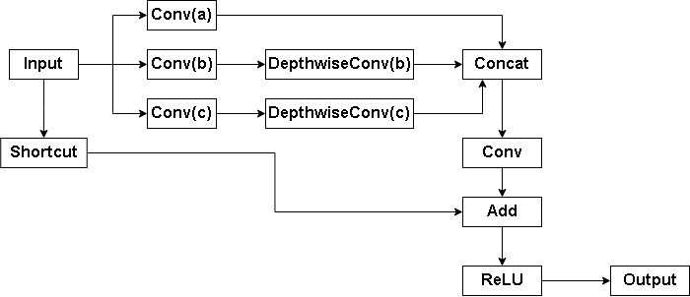

Figure 36: Depthwise-Inception-ResNet Block-A

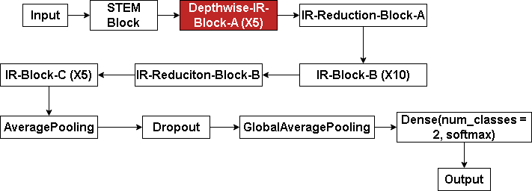

Figure 37: Depthwise-Inception-ResNet

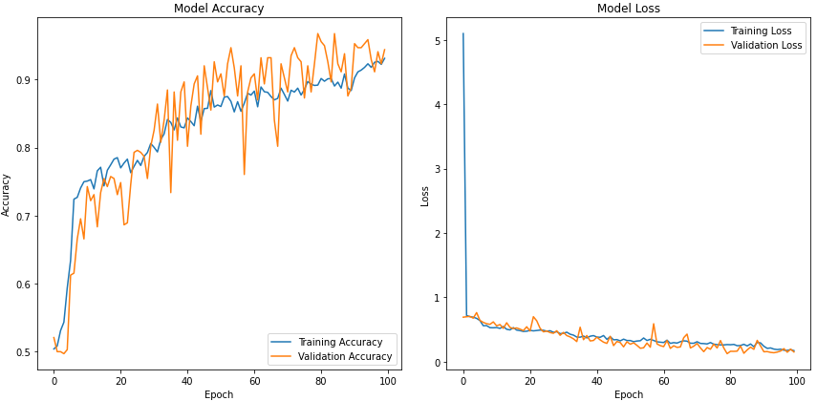

|  |  |
| --- | --- |
| 1. Train Acc = 0.9310, Val Acc = 0.9438 | 1. Train Loss = 0.1699, Val Loss = 0.1496 |

Figure 38 (ac) and (ad) demonstrate Depthwise-Inception-ResNet Train, Validation Accuracy and Loss on 40X Magnified Images

### **Current Experiments Results Summary**

This part will summarize the experiments taken during the progress of the project.

As mentioned above, individual models such as Depthwise Network, InceptionNet, and ResNet, combined models like Inception-ResNet and Depthwise--Inception-ResNet were applied to the dataset so as to provide insight about how networks with these structures are able to perform and whether they are wise selections. Training the individual models on different magnifications within the dataset optimized the structure of the training thereby selecting the best magnifications to train with.

The following table 3 portrays the summary results of each experiment the last experiment with the current Depthwise-Inception-ResNet presents a rather decent result.

|  |  |  |  |
| --- | --- | --- | --- |
| **Model Name** | **Magnification & Size** | **Validation Accuracy** | **Validation Loss** |
| Individual InceptionNet | **Raw Images** |  |  |
| 40X | 0.9497 | 0.1362 |
| 100X | 0.8323 | 0.3980 |
| 200X | 0.9005 | 0.3123 |
| 400X | 0.7782 | 0.8079 |
| **Resized: 224 * 224** |  |  |
| 40X | 0.9438 | 0.1617 |
| 100x | 0.8259 | 0.4495 |
| 200x | 0.8241 | 0.4191 |
| 400x | 0.7030 | 1.0301 |
| Individual ResNet | Resize: 224*224 |  |  |
| 40X | 0.9941 | 0.0298 |
| 100X | 0.8956 | 0.6940 |
| 200X | 0.8931 | 0.5330 |
| 400X | 0.8308 | 0.8232 |
| Inception-ResNet | Resize: 244* 244 40X | 0.9467 | 0.1354 |
| Depthwise-CNN | Resize: 244*244 40X | 0.9763 | 0.0929 |
| Depthwise-Inception-ResNet | Resize:244*244 40X | 0.9438 | 0.1496 |

Table 3: Results Summary of Experiments

# **Project Management**

## **Activities**

|  |  |
| --- | --- |
| Phase | **Objectives** |
| 1. **Preparation(Completed)** | 1. Review breast cancer deep learning. 2. Identify and narrow issues 3. Seek possible solutions. 4. Study classification methods. |
| 1. **Deep learning knowledge absorbing**   **(Completed)** | 1. Research breast cancer symptom classification methods 2. Study at least six CNN models and relevant programming libraries. 3. Grasp loss functions, optimizers, model building, and optimization. 4. Investigate extra mechanism for suitability. |
| 1. **Data collection**   **(Completed)** | 1. Gather 2 - 3 datasets from Kaggle 2. Split them into two classes: benign & malignant 3. Decide the training and test ratio |
| 1. **Development and Implementation**   **(Uncompleted)** | 1. Build Inception-ResNet model. 2. Add depthwise into Inception-ResNet 3. Train, analyze, and compare models.   4. Optimize the chosen model and adjust hyperparameters if needed. |
| **5.Testing and Finishing up**  **(Uncompleted)** | 1. Change other similar datasets to check the generalization capability of the model 2. Analyze the results and summarize the work   3. Write Project Report and Prepare presentation |

Table 4: Activities of the Project

## **Schedule**

The schedule is shown as table 5 below

**For instance**: 1- 1 means Phase 1, Objective 1, and those finished activities are marked from purple to pink. The unfinished part is marked with green.

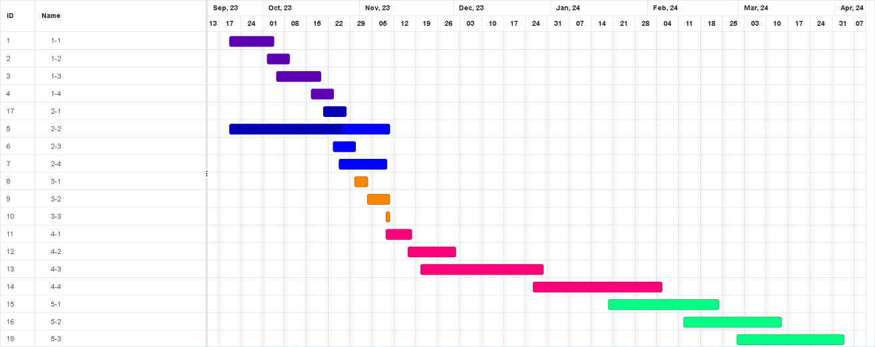

Table 5: Gantt Chart

## **Project Version Management**

To manage the different versions of codes modification, I plan to use Github as the version management tools for keeping code updated and secure.

URL is as follow: <https://github.com/Vio1etV/Final_Year_Project>

|  |  |  |  |
| --- | --- | --- | --- |
| Version Number | Code Name | Content | Results |
| 1 | Individual Model Codes for basic model testing | Individual model codes, design structure diagram, Pre-train model, h5 files etc  Original Dataset, Modified Dataset, Datasets backups | The training results, csv file that contains the each epoch for later comparison |
| 2 | Few Combinations of models | The code for combination of the models  Record of each combination | CSV of the each epoch for later comparison |
| 3 | A model which is similar to the final codes  Reference code of different structure of CNN | The codes for different version of Depthwise-Inception-ResNet  Records of each run with different parameters | CSV of each epoch for later comparison |

Table 6: Version Control Progress

## **Project Data Management**

1. All files including datasets, model codes, references, weekly reports and all sorts will be replicated into three copies for fail safe, one on local computer, one on hard drive, one on github
2. Upload the project to github for every modification, synchronize the project on three platforms

Following are documents of the Project for uploading and synchronization:

1. Reports (Weekly, Proposal, Progress, Final) & Presentation PPT
2. CNN model diagram
3. References
4. Datasets Link
5. Model evaluation documents
6. CNN model codes (Different versions)

## **Project Deliverables**

1. The project proposal
2. Weekly report
3. Progress Report
4. Final Project Report
5. Project codes
6. Project presentation slides
7. Project presentation

# **Professional Issues and Risk:**

## **Risk Analysis**

Table 7 displays the analyzed risks during the project progress.

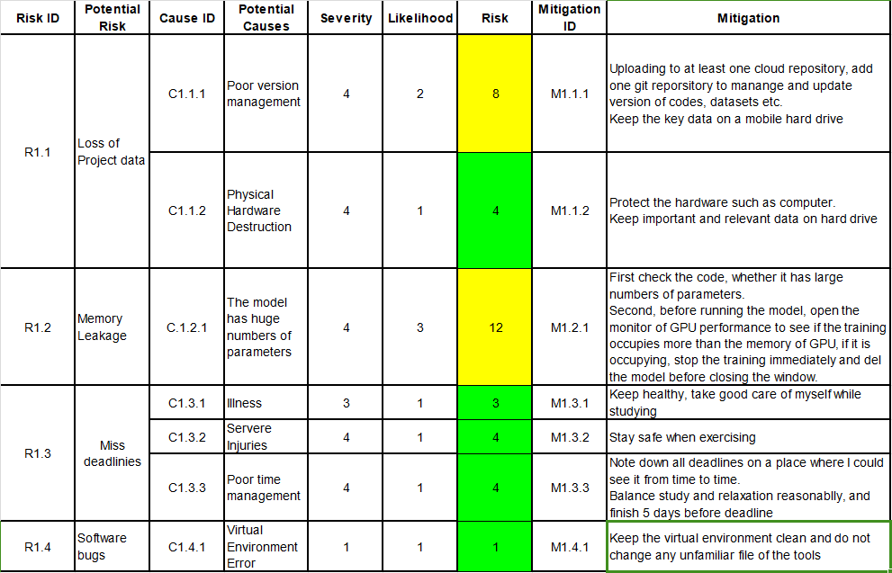

Table 7: Risk Analysis

## **Professional Issues**

Identification and discussion of relevant legal, social, ethical and environmental issues in the context of the project. Refer to professional codes of conduct, e.g. BCS, ACM.

**Legal:** In the legal aspect, using deep learning models for breast cancer detection involves issues of data privacy and protection, liability and malpractice, and intellectual property. For instance, under regulations like GDPR and HIPAA, handling personal health data requires strict adherence to privacy and security standards. To address these issues, it's essential to anonymize patient data, establish clear liability protocols, and navigate intellectual property rights carefully, ensuring compliance with existing laws and ethical standards.

**Social:** In the social context, using deep learning for breast cancer detection involves ensuring equitable access and building public trust. It's important to make this technology widely accessible to avoid healthcare disparities and to communicate its benefits and limitations clearly to foster public acceptance.

**Ethical:** Ethically, using deep learning for breast cancer detection requires addressing biases for fair diagnosis across all demographics, ensuring the AI models are transparent and understandable, and maintaining informed consent from patients about the use of such technology in their healthcare.

**Environment:** From an environmental perspective, the use of deep learning models in breast cancer detection has implications such as a significant energy consumption and carbon footprint due to the computational intensity of training these models. It's important to consider and strive for energy-efficient computing practices to mitigate this impact.

Using deep learning for breast cancer detection raises complex legal, social, ethical, and environmental considerations, including data privacy, equitable access, algorithmic fairness, transparency, and energy efficiency. If handled and operated properly, the aforementioned issues associated with using deep learning for breast cancer detection can be effectively mitigated.

# **References**

[1] I. Hirra et al., "Breast Cancer Classification From Histopathological Images Using Patch-Based Deep Learning Modeling," in IEEE Access, vol. 9, pp. 24273-24287, 2021, doi: 10.1109/ACCESS.2021.3056516.

[2] M. Desai and M. Shah, ‘An anatomization on breast cancer detection and diagnosis employing multi-layer perceptron neural network (MLP) and Convolutional neural network (CNN)’, *Clin. EHealth*, vol. 4, pp. 1–11, Jan. 2021, doi:10.1016/j.ceh.2020.11.002.

[3] G. Hamed, M. Marey, S. E. Amin and M. F. Tolba, "Automated Breast Cancer Detection and Classification in Full Field Digital Mammograms Using Two Full and Cropped Detection Paths Approach," in IEEE Access, vol. 9, pp. 116898- 116913, 2021, doi: 10.1109/ACCESS.2021.3105924.

[4] F. F. Ting, Y. J. Tan, and K. S. Sim, ‘Convolutional neural network improvement for breast cancer classification’, *Expert Syst. Appl.*, vol. 120, pp. 103–115, Apr. 2019, doi: 10.1016/j.eswa.2018.11.008.

[5] H. Aljuaid, N. Alturki, N. Alsubaie, L. Cavallaro, and A. Liotta, ‘Computer-aided diagnosis for breast cancer classification using deep neural networks and transfer learning’, *Comput. Methods Programs Biomed.*, vol. 223, p. 106951, Aug. 2022, doi: 10.1016/j.cmpb.2022.106951.

[6] A. Sahu, P. K. Das, and S. Meher, ‘An efficient deep learning scheme to detect breast cancer using mammogram and ultrasound breast images’,*Biomed.Signal Process. Control*,vol. 87, p. 105377, Jan. 2024, doi:10.1016/j.bspc.2023.105377.

[7] H. Lee, J. Park and J. Y. Hwang, "Channel Attention Module With Multiscale Grid Average Pooling for Breast Cancer Segmentation in an Ultrasound Image," in IEEE Transactions on Ultrasonics, Ferroelectrics, and Frequency Control, vol. 67, no.7, pp. 1344-1353, July 2020, doi: 10.1109/TUFFC.2020.2972573.

[8] H. Wang, X. Shen, K. Fang, Z. Dai, G. Wei, and L.-F. Chen, “Contrast-enhanced magnetic resonance image segmentation based on improved U-Net and Inception-ResNet in the diagnosis of spinal metastases,” *Journal of Bone Oncology*, vol. 42, p.100498, Oct. 2023, doi: 10.1016/j.jbo.2023.100498.

[9] Y. Liang and Z. Meng, "Brea-Net: An Interpretable Dual-Attention Network for Imbalanced Breast Cancer Classification," in IEEE Access, vol. 11, pp. 100508- 100517, 2023, doi: 10.1109/ACCESS.2023.3314978.

[10] H. Lee, J. Park and J. Y. Hwang, "Channel Attention Module With Multiscale Grid Average Pooling for Breast Cancer Segmentation in an Ultrasound Image," in IEEE Transactions on Ultrasonics, Ferroelectrics, and Frequency Control, vol. 67, no. 7, pp. 1344-1353, July 2020, doi: 10.1109/TUFFC.2020.2972573.

[11] I. U. Haq, H. Ali, H. Y. Wang, C. Lei, and H. Ali, ‘Feature fusion and Ensemble learning-based CNN model for mammographic image classification’, *J. King Saud Univ. - Comput. Inf. Sci.*, vol. 34, no. 6, Part B, pp. 3310–3318, Jun. 2022, doi: 10.1016/j.jksuci.2022.03.023.

[12] E. Alkhaldi and E. Salari, "Ensemble Optimization for Invasive Ductal Carcinoma (IDC) Classification Using Differential Cartesian Genetic Programming," in IEEE Access, vol. 10, pp. 128790-128799, 2022, doi: 10.1109/ACCESS.2022.3228176.

[13] B. Xu et al., "Attention by Selection: A Deep Selective Attention Approach to Breast Cancer Classification," in IEEE Transactions on Medical Imaging, vol. 39, no. 6, pp. 1930-1941, June 2020, doi: 10.1109/TMI.2019.2962013.

[14] N. Wu et al., "Deep Neural Networks Improve Radiologists’ Performance in Breast Cancer Screening," in IEEE Transactions on Medical Imaging, vol. 39, no. 4, pp. 1184-1194, April 2020, doi: 10.1109/TMI.2019.2945514.

[15] H. Chougrad, H. Zouaki, and O. Alheyane, “Deep Convolutional Neural Networks for breast cancer screening,” *Computer Methods and Programs in Biomedicine*, vol. 157, pp. 19–30, Apr. 2018, doi: 10.1016/j.cmpb.2018.01.011.

[16] X. Yu, C. Kang, D. S. Guttery, S. Kadry, Y. Chen and Y. -D. Zhang, "ResNet- SCDA- 50 for Breast Abnormality Classification," in IEEE/ACM Transactions on Computational Biology and Bioinformatics, vol. 18, no. 1, pp. 94-102, 1 Jan.-Feb. 2021, doi: 10.1109/TCBB.2020.2986544.

[17] N. Arya and S. Saha, "Multi-Modal Classification for Human Breast Cancer Prognosis Prediction: Proposal of Deep-Learning Based Stacked Ensemble Model," in IEEE/ACM Transactions on Computational Biology and Bioinformatics, vol. 19, no. 2, pp. 1032-1041, 1 March-April 2022, doi: 10.1109/TCBB.2020.3018467.

[18] R. Athilakshmi, R. Jansi and R. Upadhyay, "Enhancing Diabetic Retinopathy Diagnosis with Inception v4: A Deep Learning Approach," 2023 5th International Conference on Inventive Research in Computing Applications (ICIRCA), Coimbatore, India, 2023, pp. 905-910, doi: 10.1109/ICIRCA57980.2023.10220890.

[19] C. Szegedy, S. Ioffe, V. Vanhoucke, and A. Alemi, ‘Inception-v4, Inception- ResNet and the Impact of Residual Connections on Learning’. arXiv, Aug. 23, 2016. doi: 10.48550/arXiv.1602.07261.

[20] Y. Jiang, Z. Huang, L. Li, and Q. Dong, “Local-global dual attention network (LGANet) for population estimation using remote sensing imagery,” *Resources, Environment and Sustainability*, vol. 14, pp. 100136–100136, Dec. 2023, doi: 10.1016/j.resenv.2023.100136.

[21] Anjar Wanto, Yuhandri Yuhandri, and Okfalisa Okfalisa, “Optimization Accuracy of CNN Model by Utilizing CLAHE Parameters in Image Classification Problems,” Aug. 2023, doi: https://doi.org/10.1109/iconnect56593.2023.10327100.